UNIT 13

Reactions to the
Political Revolutions


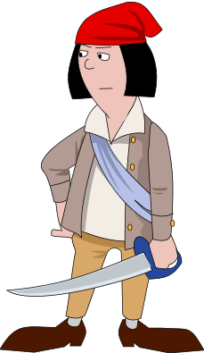

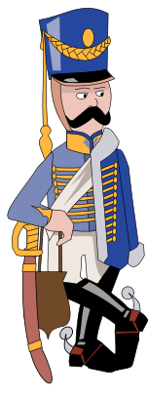
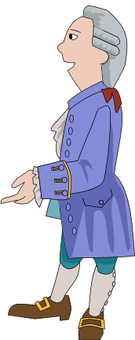

Reactions to the
Political Revolutions

Napoleon Bonaparte
Timeline

Reactions Against
the Political Revolutions

Western Europe
Latin America

Russia

I. Timeline of Political Revolutions

II. Rise of Napoleon

Napoleon Bonaparte:

How he improved France:



Napoleon’s Empire:

How he impacted Europe:

II. Reactions Against the Political Revolutions

Reactions In Europe

- Congress of Vienna:

  - Conservatism:

  - Balance of Power:

- 1848:

- Unification of Germany:

- Unification of Italy:

Nationalism
If you don’t have your own nation yet:

- Unify:

- Divide:

- Independence

If you already have your own nation:

In Russia

- Reaction against the French Revolution:

- 19th Century Serfdom:

- Emancipation of the Serfs:

- Conditions in Russia at the end of the 1800s:
Reactions in Latin America (reactions against Revolutions cont.)

- Failure of Democracy:

- Church and Military:

- Overall Conditions in Latin America in the 1800’s

**********************************************************************************
Case Study - The Mexican Revolution

Causes:

Important Persons:

Diaz:

Zapata:

Villa:

Impact:

- constitution:

- social reforms:

- economic nationalism:

- cultural nationalism:
VII. Essential Questions

1. A. How did the concept of nationalism help Napoleon build his empire?

B. How did nationalism lead to Napoleon’s defeat?

2. Even though Napoleon spread the ideas of the French Revolution – why did these ideas fail to
bring about great political change in Europe?

Unit 14

Industrial Revolution

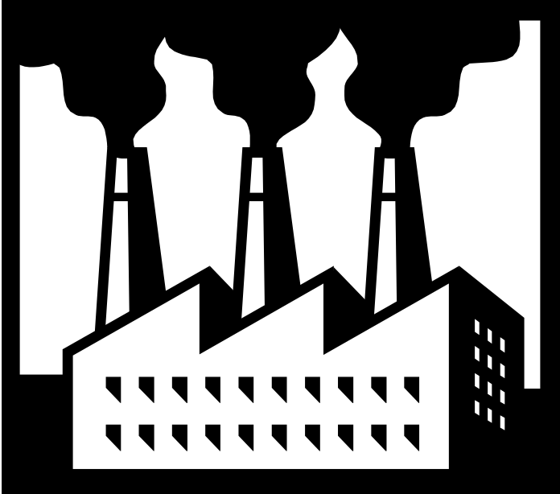

Industrial Revolution
Timeline

Agricultural Revolution

Changes in Agriculture
Results of the Changes
Domestic System vs
Factory System
Needs of Industry:
Case Study: Great Britain

Industrial Revolution

Effects of Industrialization
Reactions to the Industrial Revolution

Attempts at Reforming Society
Global Migration

The Arts
Essential Questions

I. Timeline of the Industrial Revolution

II. The Agricultural Revolution

Agricultural Revolution:

CHANGES



RESULTS

III. The Industrial Revolution


Industrial Revolution:

Domestic System:


Factory System:
What a Nation needs to have Industry


How Industrialization Effected Society


- Urbanization

- Working Conditions

- child labor:

- long hours:

- dangerous conditions

- Changing Social Roles

- women:

- family:

- children:

- Transportation

Reactions to the Industrial Revolution

- Liberalism vs. Conservatism:

Liberals Conservatives

- Adam Smith:

- Thomas Malthus:

- Charles Darwin:

- Socialism:

Utopian Socialism:

Marxist Socialism:

The Arts

- Romanticism:

- Realism:

- Impressionism:

Attempts to Reform Society:

- Sadler Report:


- Education:

- Suffrage:

- Labor Legislation:

  - Safety conditions:

  - Women and children:

  - Trade Unions:

Global Migrations:

CAUSES

- Social Causes:

-

-

-

- Political Causes:

- Improved Transportation:

-

-

EXAMPLES

IV. Essential Questions

1. How did the Agricultural Revolution support the Industrial Revolution?

2. How can the Industrial Revolution be considered the major turning point in History?

3. How did the abuses of the Industrial Revolution lead to the competing ideologies for social
change?

4. Compare and Contrast the ideas of Adam Smith and Karl Marx:

Capitalism – Adam Smith Socialism – Karl Marx

Definition

Supporting
Theory

Role of
The Government

Ownership of
the means of
production

Unit 15

Imperialism

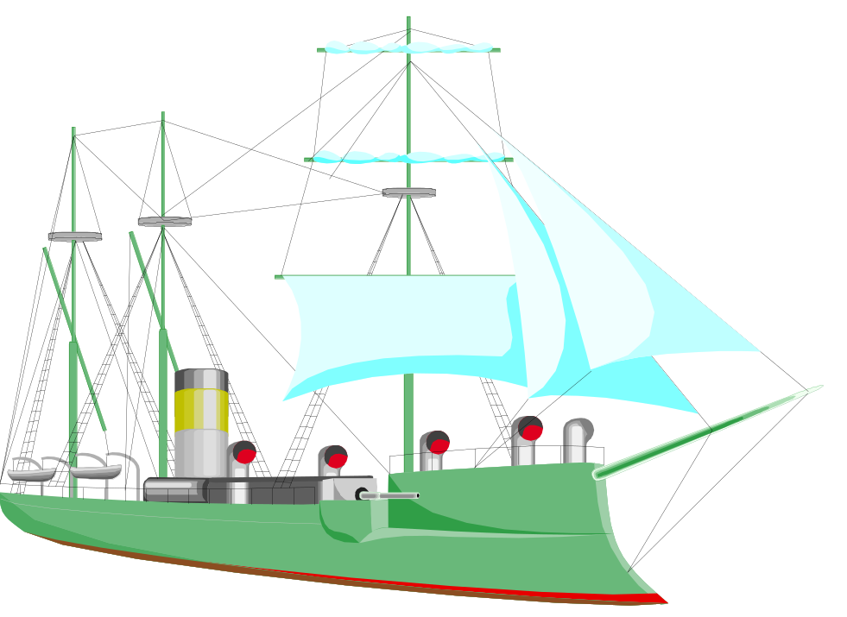

Imperialism

Map
Timeline

Imperialism

European Imperialism
Japanese Imperialism

I. Map - World Imperialism – 19th Century

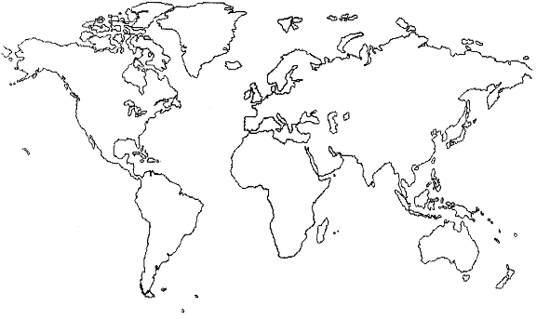


II. Timeline - World Imperialism

Imperialism:

III. European Imperialism

Where What Happened Main Events Important Information

AFRICA

INDIA

CHINA

Reasons why Europeans Imperialized other areas

- Nationalistic:

- Political:

- Economic:

- White Man’s Burden:

Negative effects on the native peoples

Positive Effects on the native peoples

IV. Japanese Imperialism

- 1600’s:

- Mid 1800’s - Treaty of Kanagawa:

- Meiji Restoration:

- Westernization:

- Japanese Imperialism:

- Sino-Japanese War:

- Russo-Japanese War:

- Industrial needs:

V. Essential Questions

1. What was the relationship between Nationalism – Industrialization – and Imperialism?

2. How could native peoples find Imperialism by Europeans to be both a negative and a positive experience?

UNIT 16

The World Wars

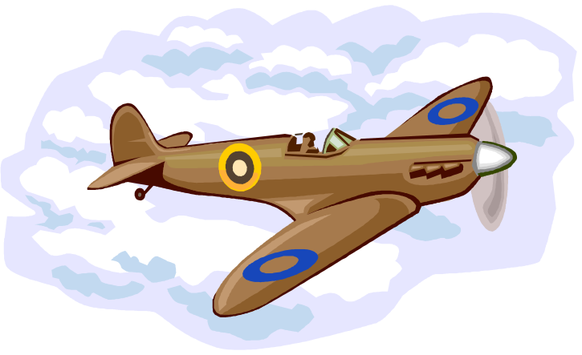

The World Wars
Timeline
Map 1: Europe: Before the World Wars
Causes
Warfare

World War I

Art and Literature
Results

Map 2: Europe between the Wars

Hitler’s Rise to Power
Hitler’s Germany

Between the Wars

Causes Warfare Causes Warfare

In Europe
In Asia

World War II

Results Results
Map 3: Europe after World War II

Essential Questions

I. Map - Europe Before the World Wars

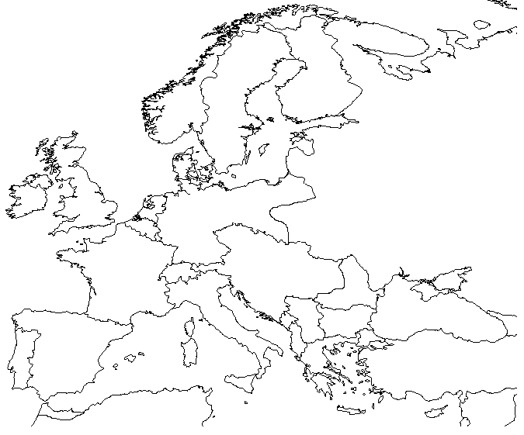

II. Map - Europe Between the Wars

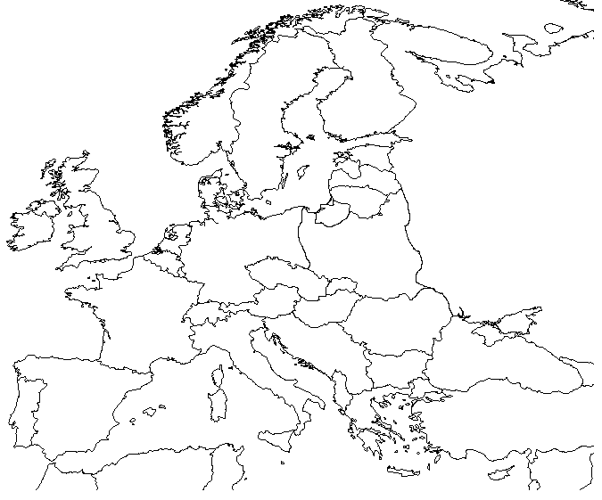

III. Map - Europe After the World Wars

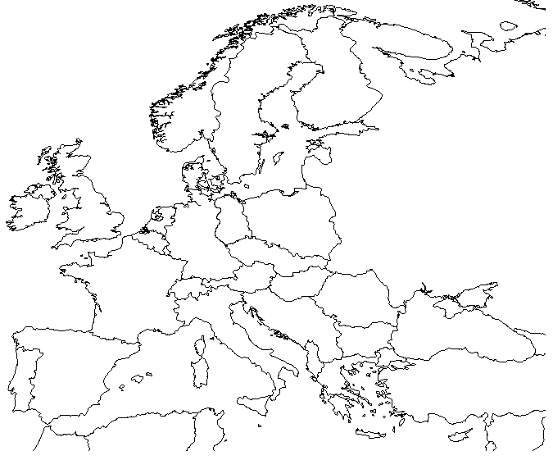

IV. Timeline - The World Wars

V. World War I

Causes of World War I

Type of Warfare

- Trench:

- New Technologies:

Art and Literature

- Propaganda:

- All Quiet on the Western Front:

Results of World War I

- Treaty of Versailles:

- League of Nations:

- New map of Europe:

VI. Europe Between the Wars

Hitler’s Rise to Power

- Economic Environment:

-

-

- Reasons why Hitler came to power in Germany

-

-

-

Hitler’s Germany

- Totalitarian Government

- Holocaust

VII. World War II in Europe

Causes

Warfare

- mobile warfare:

- technologies:

- key events:

Results

VIII. World War II in Asia

Causes

The War

- Japanese abuses:

- Island Hopping:

- Atomic Bomb:

Results

IX. Essential Questions

1. How were the results of World War I directly related to the causes of World War II in Europe?

2. How did the memories of World War I lead some European nations to allow German
Aggression?

3. How did Hitler use the social, economic, and political conditions in Germany after
World War I to help him rise to power?

4. How does the relationship between a government and an individual citizen differ when comparing Hitler’s Germany and Western Democracies?

5. In what way did each of the allies view their contribution as essential to the war effort?

UNIT 17

Communism

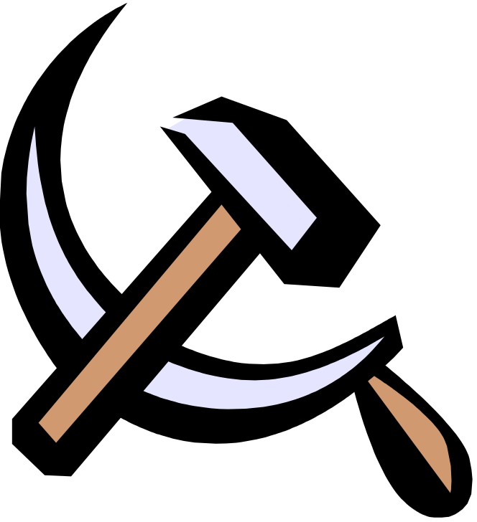

Communism

Lenin’s USSR
Stalin’s USSR

Russian Revolution
The Cold War

U.S.S.R.

Fall of the USSR

Origins of Communism

Communism

Korea
Chinese Republic
Vietnam
Other Communist Governments

China

Cuba

Communist China
Case Study:
Compare
Stalin’s USSR with Mao’s China

I. Map – Soviet Union and Satellite Nations

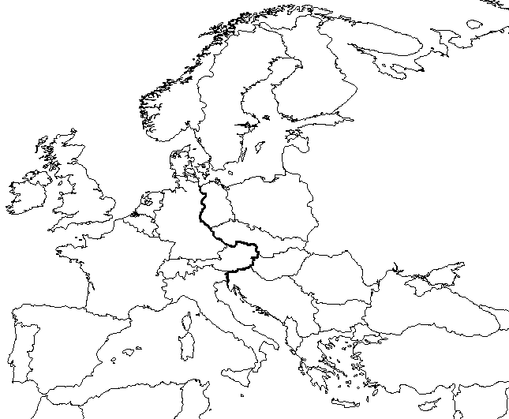

Map – Russia and Neighbors after the Fall of Communism

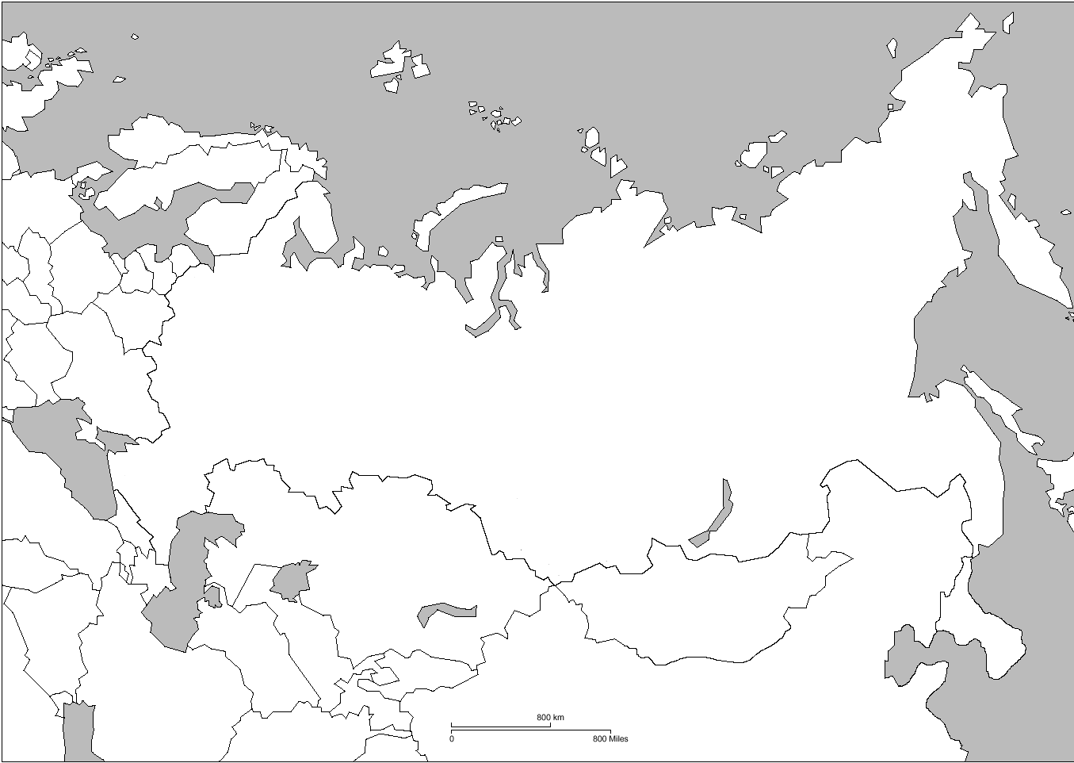

II. Timeline of Communism in the 20th Century

III. Origins of Communism

- Karl Marx:

- Communism

  - Socialism:

  - Communism:

  - Marxism:

IV. Communism comes to Russia

- Life under the Czar:

- The Provisional Government:

- The Bolsheviks:

- 1917 Revolution:

- Russian Civil War:

V. Lenin’s U.S.S.R.

- The U. S. S. R.:

- New Economic Policy:

VI. Stalin’s U.S.S.R.

- Joseph Stalin:

- Totalitarian State:

- Collectivization:

- 5 Year Plan:

- Purges:

- World War II:

VII. The Cold War

Roots of the Cold War

Cold war Terms

- Iron curtain:

- Eastern bloc:

- “satellites”:

The 2 Sides

Alliance

Leading Nation

Foreign Policy

Economic System

Type of Government

Events of the Cold War

- Marshall Plan / Truman Doctrine:

- Berlin Airlift:

- Arms Race:

- Space Race:

- Berlin Wall:

- Cuban Missile Crisis:

- Détente:

VIII. Fall of the USSR

Causes

- Changing of the Guard:

- Glasnost:

- Perestroika:

- Failure of the Economy:

- Challenges to Soviet control of satellite nations:

- Break-up of the USSR:

Results of the Fall Of the USSR

- New Nations formed:

- Effects on world Communism:

- Ending of the Cold War: End of the USSR → end of the “Cold War”
IX. Communism in China

The Chinese Republic

- Manchu Dynasty:

- Revolution of 1911:

- Nationalist Party:

- Sun Yixian:

- Jiang Jieshi:

Rise of Communism in China

- When:

- Reasons:

- Mao Zedong:

- Chinese Communist Revolution:

- The “Long March”:

- Japan / World War II:

- Communist Victory:

Communist China:

- The People’s Republic of China:

- Mao’s China:

- Great Leap Forward:

- Cultural Revolution:

Deng’s China:

- Deng Xioping:

- Economic Reform:

- Anti-Communist Protests:

Recent Events

- Hu Jintao:

- Return of Hong Kong:

X. Other Communist Governments

Korea

- The Partition:

- Korean War:

Vietnam

- Colonial History:

- Ho Chi Minh:

- Vietnam War:

Cuba

- Location:

- Historical Past:

Relationship with the U.S. Today:
XI. Case Study

Let’s Compare Stalin’s USSR – with Mao’s China

Stalin’s USSR Mao’s China

Type of Rule

Economic Plans

Dealing with their
Opposition

Relations with
Western Nations

Reactions after
Their deaths

XII. Essential Questions

1. Why did Communism appeal to the peasant societies in both Russia and China?

2. Why did attempts at democratic reform succeed in the USSR but fail in China?

3. Why did Communism, as an economic system, fail in the USSR?

4. How can it be argued that Communism, as an economic system, is failing in China today?

5. Why were the Communist under Deng Xioping willing to adopt elements of Western market economies – but not the West’s concept of human rights?

Unit 18

Post WW II - Nationalism

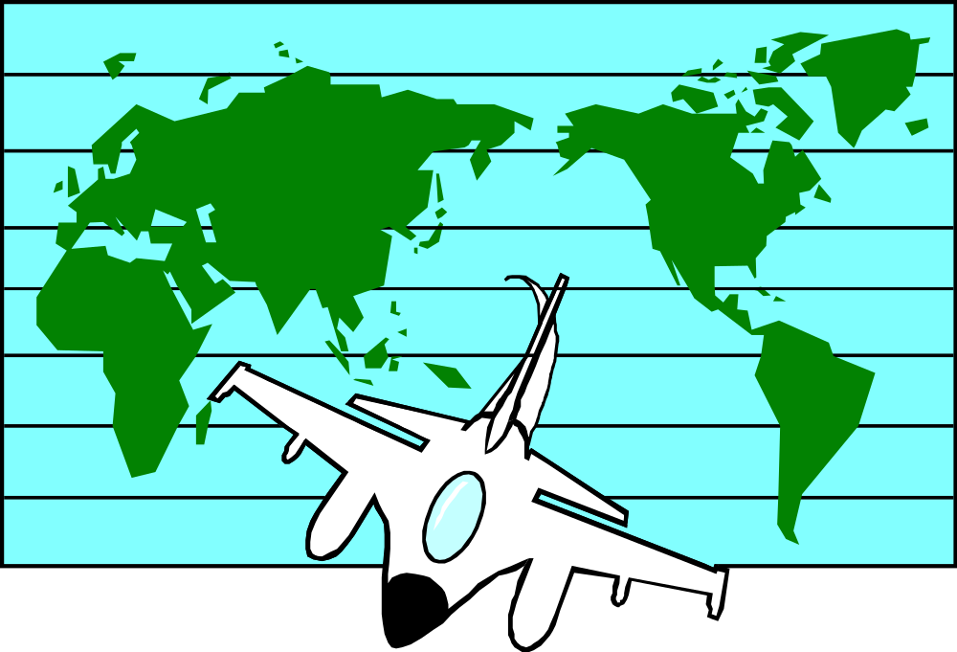

Post WWII – Nationalism

Timeline

Map
Essential Questions
Case Study
Pre-WWII Turkey

Post WWII - Nationalism

Nationalism in Africa
Nationalism in India

Nationalism in Southeast Asia

I. Map – Post World War II Nationalism Areas
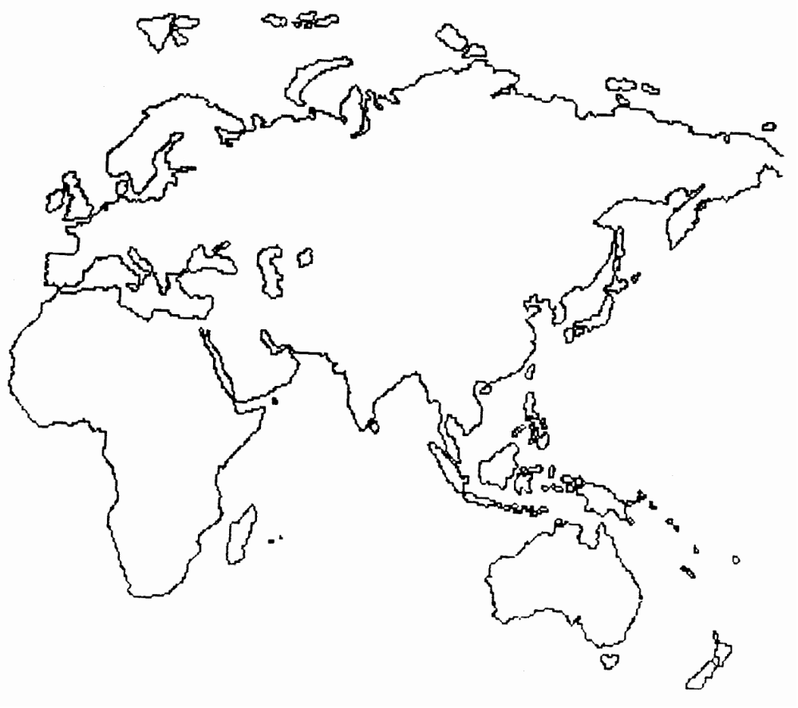

II. Timeline of Post WWII – Nationalism

Case Study – Nationalism in Turkey

Kemal Ataturk:

How he changed Turkey:

III. Nationalism in Africa
Apartheid

History

ANC

Leaders

- Nelson Mandela:

- Bishop Desmond Tutu:

- F.W. DeKlerk:

- Pre-World War II:

- World War II:

- Post- World War II:

Important Independence Movements

- Ghana:

- Kenya:

After Independence

- Gradualism

- British Commonwealth

Ethnic Rivalries:

- Nigeria:

- Rwanda:
IV. Nationalism in India

Colonial History

Attempts at Nationalism

- Indian National Congress:

- Muslim League:

Important Leaders

- Mohandas Gandhi:

- Jawaharlal Nehru:

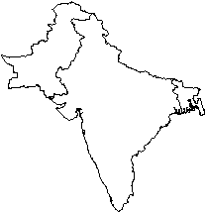Independence

- 1947:

- Partition:

Recent Issues

- Non-Alignment:

- Kashmir and Punjab:

- Pakistan:

V. Nationalism in Southeast Asia

Vietnam

- As a French Colony:

- Ho Chi Minh:

- Dienbeinphu:

- U.S. Involvement:

- Domino Theory:

- Viet Cong:

Results:

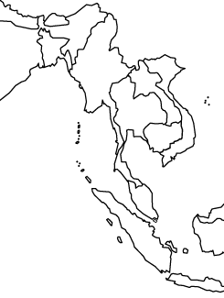

Cambodia

- Khmer Rouge:

- Pol Pot:

Myanmar:

- Colonial History:

- Aung San Suu Kyi:
VI. Essential Questions

1. Why did most European colonial empires collapse around the world following World War II?

2. Even though political independence has been achieved in Africa and Asia, in what ways are former colonies still connected culturally to their former rulers?

3. In what way was the Vietnamese reason for fighting the Vietnam War different than the American reason for fighting the war?

Unit 19

Recent World Conflicts

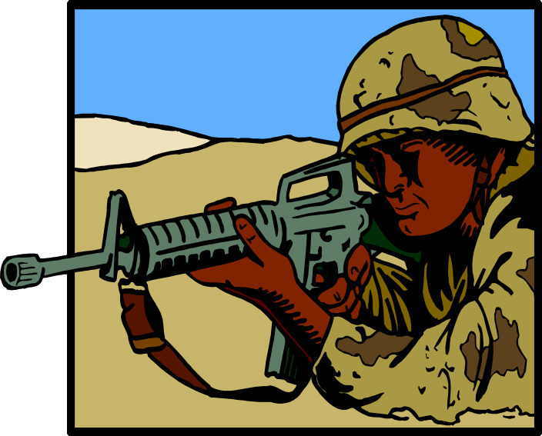

Recent World Conflicts

Timeline

Israel
Middle East
Maps
Essential
Questions
World

Recent World Conflicts

“Political”
Hotspots
“Ethnic”
Hotspots

Case Study:

The Middle East

I. Map: World Conflict Areas
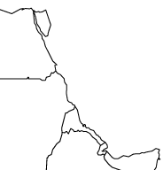
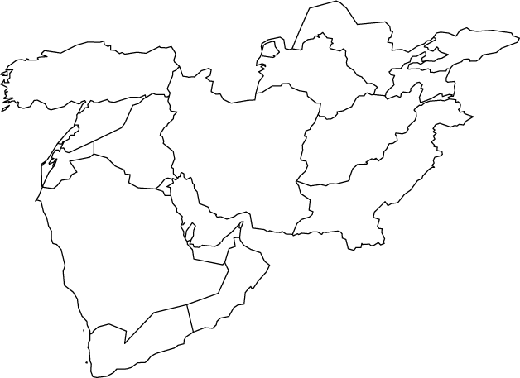
II. Map: The Middle East
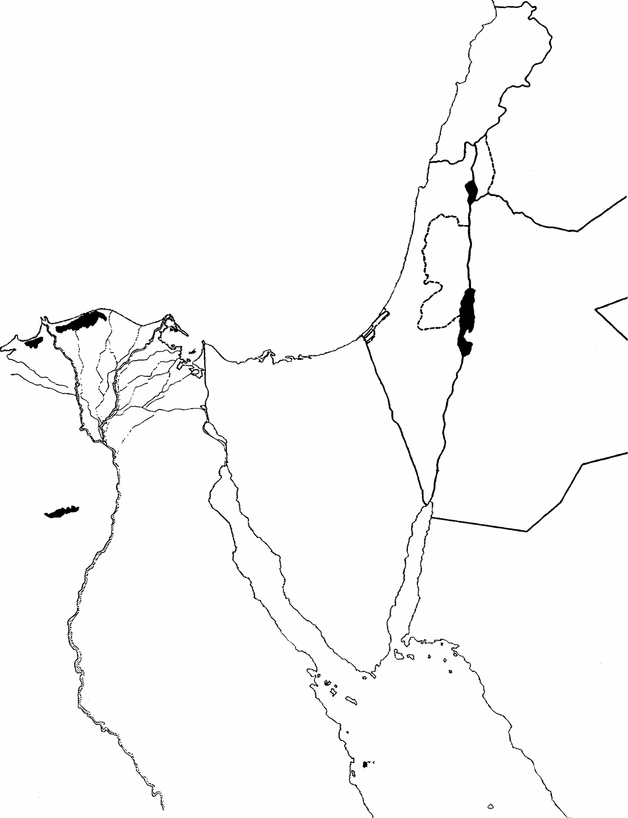
III. Map: Israel-Palestine

IV. Timeline: Recent World Conflicts

I. Important Terms

- conflict:

- hotspot:

- “political” hotspot:

- “ethnic” hotspot:

VI. Recent “Ethnic” Hotspots

Hotspot The 2 Sides Important Information

VII. Recent “Political” Hotspots

Hotspot The 2 Sides Important Information

VIII. Case Study: The Middle East

A. The Israel/Palestine Issue

- Zionism:

- Balfour Declaration:

- U.N. Partition:

- Wars:

- The Jews:

- The Palestinians:

  - The PLO:

  - Yassir Arafat:

  - Terrorism:

- Camp David Accords:

- Recent news:

B. The Iranian Revolution

- Cause of the Revolution:

- Main Event:

- Rise of Islamic Fundamentalism:

C. Islamic Fundamentalism

- Foundations:

- Iran – Iraq War:

- Terrorism:

- Islamic Jihad/Hezbollah/Al Qaeda

D. The Persian Gulf War

Causes:

The War:

Results

- Short Term Results:

- Long term Results:

E. U.S. – Iraq War

Causes:

War:

Results:

IX. Essential Questions

1. What are the differences and similarities between “political” and “ethnic” hotspots?

- Differences:

- Similarities:

2. What role have outsiders such as the United States, the United Nations, and Egypt played in
attempting to help solve the Israel/Palestine conflict in the Middle East?

3. What other roles has the United States and the United Nations played in attempting to settle other
conflicts in the Middle East?

4. Why have the conflicts in the Middle East been so difficult to resolve?

Unit 20

Modern World Economic Issues



Modern World Economic Issues

North
vs.
South
Issues

Types of Economic Systems

Modern World Economic Issues

International
Trading Agreements

Rise of the Pacific economic community

Essential
Questions

I. Types of Economic Systems

TYPE Who owns the businesses? Who makes the economic Examples
decisions?

II. International Trading Agreements

NAFTA

OPEC

European Union

III. North vs. South Issues

North vs. South? :

“developing” nations:

Characteristics of a developing nation:

International Assistance Organizations:

IV. Rise of the Pacific Economic Community

Re-emergence of Japan

Rise of “Asian Tigers”

V. Essential Questions

1. What factors make building a strong economy difficult in developing nations?

2. In what ways have nations become more economically interdependent since World War II?

Interdependence:

3. To what extent have economic disparities between developed and developing nations persisted or increased?

Unit 21

Global Issues


Global Issues

Global
Migration

The Role of the United Nations

The
Status of Women and Children

Global Issues

Traditional
vs.
Modernization
Science
And
Technology

Global
Problems

Essential
Questions

I. The United Nations

- United Nations:

- General Assembly:

- Security Council:

Role as Peacekeepers

Social and Economic Programs

II. Traditional vs. Modernization

traditional:

modernized:

- Japan:

- The Middle East:

III. Global Migration

Global migration:

Reasons why people migrate:

IV. The Status of Women and Children

WOMEN

- Traditional Societies:

- Muslim Societies:

CHILDREN

- Labor Issues:

- Infanticide:

V. Science and Technology

Green Revolution:

Information Age:

Space Age:

Medical Technology:
VI. Global Problems

Problem Place Cause Effect Solution

Problem Place Cause Effect Solution

VII. The Last Essential Questions ☺

1. To what extent are current migrations similar to earlier world migrations? How are they different?

2. What impact has the scientific and technical advances of recent years had on the following:

  - life expectancy:

  - war:

  - peace:

3. What are some of the negative impacts of modernization on developing nations?

4. What are some negative impacts of urbanization on modern societies?

5. What factors determine whether or not a nation is considered to be overpopulated?

6. Terrorism and Nuclear Proliferation – how can the combination of these two concepts be viewed as the greatest threat to our world today?

